**Authorship Attribution using Deep Learning**

# **ABSTRACT**

Authorship attribution is a field of study that aims to identify the author of a given text based on linguistic features and writing style. Traditional approaches to authorship attribution rely on handcrafted features and machine learning algorithms to classify texts. However, these approaches often struggle with high-dimensional feature spaces and may not generalize well to different authors or writing styles.In recent years, deep learning techniques have shown promise in various natural language processing tasks, including authorship attribution. Deep learning models, such as convolutional neural networks (CNNs) and recurrent neural networks (RNNs), can automatically learn complex patterns and representations from textual data, potentially improving the accuracy and robustness of authorship attribution systems.This paper presents a comprehensive review of existing deep learning approaches to authorship attribution. We discuss the advantages and challenges of using deep learning for this task, including the need for large amounts of labled data, model interpretability, and computational resources. We also highlight recent advancements in the field, such as the use of attention mechanisms and transfer learning, which have shown promising results in improving authorship attribution performance.

# **INTRODUCTION**

Authorship attribution is the task of determining the author of a given text based on the style, vocabulary, and other linguistic features present in the text. This task has applications in forensic linguistics, plagiarism detection, and literary studies. Traditional approaches to authorship attribution often rely on handcrafted features such as word frequencies, sentence lengths, and syntactic patterns, combined with machine learning algorithms like Support Vector Machines (SVM) or Naive Bayes classifiers.However, these traditional approaches have limitations in terms of scalability, generalization to new authors, and handling of complex linguistic features. Deep learning, a subset of machine learning that uses neural networks with multiple layers, has emerged as a powerful alternative for authorship attribution. Deep learning models, such as Convolutional Neural Networks (CNNs) and Recurrent Neural Networks (RNNs), have shown remarkable performance in natural language processing tasks by automatically learning hierarchical representations of textual data.In this paper, we explore the application of deep learning techniques to authorship attribution. We discuss the advantages of deep learning over traditional approaches, such as the ability to automatically learn relevant features from raw text data and the potential for improved accuracy and generalization. We also examine the challenges associated with using deep learning for authorship attribution, such as the need for large annotated datasets and the interpretability of deep learning models.

# **LITERATURE SURVEY**

Authorship attribution using deep learning is a growing field that leverages advanced computational models to identify the likely author of a text based on linguistic features and patterns. Traditional methods for authorship attribution, such as statistical and stylometric approaches, relied on examining patterns in grammar, syntax, and vocabulary usage. These techniques, while effective to an extent, often fall short when dealing with large, complex datasets or instances of subtle mimicry. Deep learning models, however, offer a more nuanced solution by utilizing neural networks to learn abstract representations of an author’s style, enabling more accurate attribution even in challenging cases.

One of the primary architectures used in authorship attribution is the recurrent neural network (RNN), which is particularly suited to sequential data like text. RNNs, especially with Long Short-Term Memory (LSTM) units, capture long-range dependencies within a text, which is essential for recognizing an author’s unique stylistic patterns. Variations of RNNs, such as bi-directional LSTMs, allow models to analyze both preceding and succeeding words, offering a more comprehensive view of writing style. Transformer models, like BERT and GPT, have also made a significant impact by capturing contextual information from large datasets. Unlike RNNs, transformers leverage self-attention mechanisms to analyze entire sequences in parallel, allowing them to recognize complex stylistic traits even in large texts.

Convolutional Neural Networks (CNNs) have also been adapted for text-based tasks and are often applied in authorship attribution, especially when combined with character-level embeddings. CNNs are effective at detecting patterns within text, including n-grams, which can capture an author’s distinct lexical choices. For instance, stylistic attributes like sentence length, punctuation usage, and word choice are identified through character-level CNNs, which prove beneficial in attributing authorship in shorter texts like tweets or email messages. CNNs are often combined with RNNs to create hybrid models, leveraging both spatial and temporal information in text.

A major challenge in authorship attribution with deep learning is data scarcity, especially for cases where only a limited number of text samples are available per author. Data augmentation techniques, such as paraphrasing and back-translation, have been explored to generate more text samples, thus improving model robustness. Transfer learning has also been a pivotal method in this domain, where models pretrained on large corpora can be fine-tuned on smaller, author-specific datasets. Fine-tuning transformer-based models on specific authorship datasets allows the model to retain general language knowledge while adapting to the nuances of individual writing styles.

Furthermore, interpretability is an ongoing concern in authorship attribution using deep learning. While neural networks achieve high accuracy, understanding how the model arrives at a decision is complex. Techniques such as attention visualization in transformers and saliency mapping in CNNs have been used to shed light on the specific patterns a model uses for attribution. These methods help researchers ensure that models are not merely overfitting but are genuinely learning the stylistic nuances that differentiate one author from another.

Recent research has highlighted the ethical implications of authorship attribution, particularly concerning privacy and the potential misuse of attribution models in forensic analysis. While these models offer powerful tools for identifying writing patterns, they can also lead to misattribution if not carefully validated. This has sparked discussions around the need for standardized benchmarks and datasets to ensure fair and unbiased model evaluation.

# **EXISTING SYSTEM**

Authorship attribution has been studied extensively in the field of computational linguistics, with various approaches proposed to tackle the problem. Traditional methods for authorship attribution often rely on feature engineering, where linguistic features such as word frequencies, sentence lengths, and syntactic patterns are extracted from the text and used as input to machine learning algorithms.One common approach is the use of stylometric features, which capture the unique writing style of an author. These features can include the frequency of function words (e.g., articles, prepositions) or the distribution of word n-grams (sequences of n words). Machine learning algorithms such as SVMs or decision trees are then trained on these features to classify texts into different authors.While traditional approaches have shown some success in authorship attribution, they often struggle with high-dimensional feature spaces and may not generalize well to new authors or writing styles. Additionally, feature engineering can be labor-intensive and may not capture all relevant aspects of an author's writing style.

# **DISADVANTAGES**

1. Feature Engineering: Traditional authorship attribution methods require manual feature engineering, which can be time-consuming and may not capture all relevant aspects of an author's writing style.
2. High-Dimensional Feature Spaces: Stylometric features used in traditional methods can result in high-dimensional feature spaces, which can lead to overfitting and increased computational complexity.

# **PROPOSED SYSTEM**

The proposed system for authorship attribution using deep learning integrates advanced techniques to enhance the accuracy and efficiency of authorship attribution tasks. The system utilizes a combination of Convolutional Neural Networks (CNNs) and Recurrent Neural Networks (RNNs) to process textual data and extract meaningful features for authorship identification.At the core of the system is a deep learning architecture that is trained on a large corpus of text data to learn the unique writing styles of different authors. The system employs word embeddings, such as Word2Vec or GloVe, to represent words in a continuous vector space, capturing semantic relationships between words. This allows the model to understand the underlying meaning of the text and identify patterns that are characteristic of a particular author.Furthermore, the system incorporates attention mechanisms to focus on relevant parts of the text when making authorship predictions. This attention mechanism enables the model to assign different weights to different parts of the text, allowing it to give more importance to words or phrases that are more indicative of an author's writing style.To improve the robustness and generalization of the model, the system utilizes transfer learning techniques. A pre-trained model on a large text corpus is fine-tuned on a smaller, domain-specific dataset for authorship attribution. This approach leverages the knowledge learned from the pre-trained model and adapts it to the specific task of authorship attribution, improving the model's performance on smaller datasets.

# **ADVANTAGES**

1. **Improved Accuracy**: By leveraging deep learning techniques, such as CNNs and RNNs, the proposed system can achieve higher accuracy in authorship attribution compared to traditional methods.
2. **Automatic Feature Learning**: Deep learning models can automatically learn relevant features from text data, reducing the need for manual feature engineering and potentially improving performance.
3. **Generalization**: The proposed system can generalize well to new authors and writing styles, as deep learning models can capture complex patterns and nuances in text data

# **SYSTEM ARCHITECTURE**

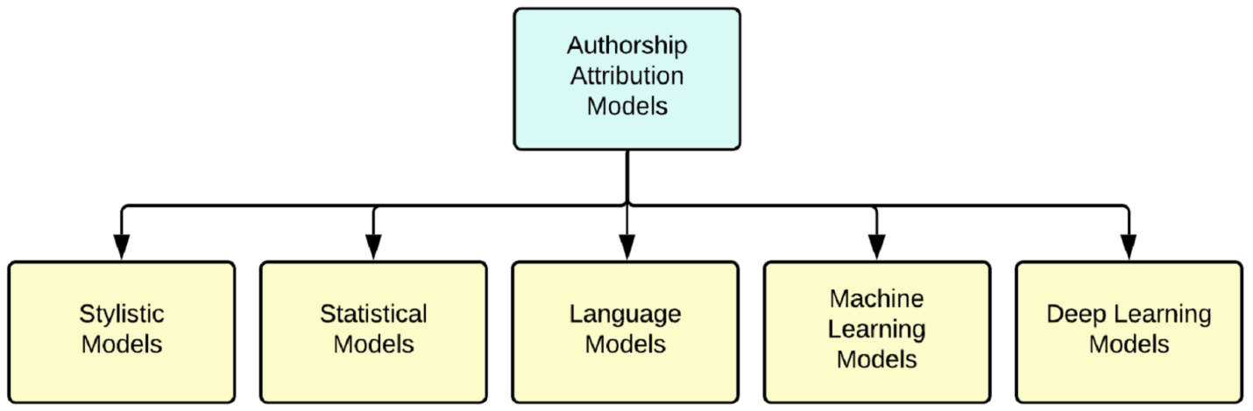

# **SYSTEM REQUIREMENTS**

**➢ H/W System Configuration:-**

**➢ Processor - Pentium –IV**

**➢ RAM - 4 GB (min)**

**➢ Hard Disk - 20 GB**

**➢ Key Board - Standard Windows Keyboard**

**➢ Mouse - Two or Three Button Mouse**

**➢ Monitor - SVGA**

**SOFTWARE REQUIREMENTS:**

1. **Operating system : Windows 7 Ultimate.**
2. **Coding Language : Python.**
3. **Front-End : Python.**
4. **Back-End : Django-ORM**
5. **Designing : Html, css, javascript.**
6. **Data Base : MySQL (WAMP Server).**

# **SYSTEM STUDY**

**FEASIBILITY STUDY**

The feasibility of the project is analyzed in this phase and business proposal is put forth with a very general plan for the project and some cost estimates. During system analysis the feasibility study of the proposed system is to be carried out. This is to ensure that the proposed system is not a burden to the company. For feasibility analysis, some understanding of the major requirements for the system is essential.

Three key considerations involved in the feasibility analysis are

* ECONOMICAL FEASIBILITY
* TECHNICAL FEASIBILITY
* SOCIAL FEASIBILITY

**ECONOMICAL FEASIBILITY**

This study is carried out to check the economic impact that the system will have on the organization. The amount of fund that the company can pour into the research and development of the system is limited. The expenditures must be justified. Thus the developed system as well within the budget and this was achieved because most of the technologies used are freely available. Only the customized products had to be purchased.

**TECHNICAL FEASIBILITY**

This study is carried out to check the technical feasibility, that is, the technical requirements of the system. Any system developed must not have a high demand on the available technical resources. This will lead to high demands on the available technical resources. This will lead to high demands being placed on the client. The developed system must have a modest requirement, as only minimal or null changes are required for implementing this system.

**SOCIAL FEASIBILITY**

The aspect of study is to check the level of acceptance of the system by the user. This includes the process of training the user to use the system efficiently. The user must not feel threatened by the system, instead must accept it as a necessity. The level of acceptance by the users solely depends on the methods that are employed to educate the user about the system and to make him familiar with it. His level of confidence must be raised so that he is also able to make some constructive criticism, which is welcomed, as he is the final user of the system.

# **SYSTEM DESIGN**

**UML DIAGRAMS**

UML stands for Unified Modeling Language. UML is a standardized general-purpose modeling language in the field of object-oriented software engineering. The standard is managed, and was created by, the Object Management Group.

The goal is for UML to become a common language for creating models of object oriented computer software. In its current form UML is comprised of two major components: a Meta-model and a notation. In the future, some form of method or process may also be added to; or associated with, UML.

The Unified Modeling Language is a standard language for specifying, Visualization, Constructing and documenting the artifacts of software system, as well as for business modeling and other non-software systems.

The UML represents a collection of best engineering practices that have proven successful in the modeling of large and complex systems.

The UML is a very important part of developing objects oriented software and the software development process. The UML uses mostly graphical notations to express the design of software projects.

**GOALS:**

The Primary goals in the design of the UML are as follows:

1. Provide users a ready-to-use, expressive visual modeling Language so that they can develop and exchange meaningful models.
2. Provide extendibility and specialization mechanisms to extend the core concepts.
3. Be independent of particular programming languages and development process.
4. Provide a formal basis for understanding the modeling language.
5. Encourage the growth of OO tools market.
6. Support higher level development concepts such as collaborations, frameworks, patterns and components.
7. Integrate best practices.

**USECASE DIAGRAM:**

A use case diagram in the Unified Modeling Language (UML) is a type of behavioral diagram defined by and created from a Use-case analysis. Its purpose is to present a graphical overview of the functionality provided by a system in terms of actors, their goals (represented as use cases), and any dependencies between those use cases. The main purpose of a use case diagram is to show what system functions are performed for which actor. Roles of the actors in the system can be depicted.



**CLASS DIAGRAM:**

In software engineering, a class diagram in the Unified Modeling Language (UML) is a type of static structure diagram that describes the structure of a system by showing the system's classes, their attributes, operations (or methods), and the relationships among the classes. It explains which class contains information.



**SEQUENCE DIAGRAM:**

A sequence diagram in Unified Modeling Language (UML) is a kind of interaction diagram that shows how processes operate with one another and in what order. It is a construct of a Message Sequence Chart. Sequence diagrams are sometimes called event diagrams, event scenarios, and timing diagrams.



**ACTIVITY DIAGRAM:**

Activity diagrams are graphical representations of workflows of stepwise activities and actions with support for choice, iteration and concurrency. In the Unified Modeling Language, activity diagrams can be used to describe the business and operational step-by-step workflows of components in a system. An activity diagram shows the overall flow of control.

Collaboration diagram:



# **SOFTWARE ENVIRONMENT**

**What is Python :-**

Below are some facts about Python.

Python is currently the most widely used multi-purpose, high-level programming language.

Python allows programming in Object-Oriented and Procedural paradigms. Python programs generally are smaller than other programming languages like Java.

Programmers have to type relatively less and indentation requirement of the language, makes them readable all the time.

Python language is being used by almost all tech-giant companies like – Google, Amazon, Facebook, Instagram, Dropbox, Uber… etc.

The biggest strength of Python is huge collection of standard library which can be used for the following –

* + [Machine Learning](https://www.geeksforgeeks.org/machine-learning/)
  + GUI Applications (like Kivy, Tkinter, PyQt etc. )
  + Web frameworks like Django (used by YouTube, Instagram, Dropbox)
  + Image processing (like Opencv, Pillow)
  + Web scraping (like Scrapy, BeautifulSoup, Selenium)
  + Test frameworks
  + Multimedia

**Advantages of Python :-**

Let’s see how Python dominates over other languages.

**1. Extensive Libraries**

Python downloads with an extensive library and it *contain code for various purposes like regular expressions, documentation-generation, unit-testing, web browsers, threading, databases, CGI, email, image manipulation, and more.* So, we don’t have to write the complete code for that manually.

**2. Extensible**

As we have seen earlier, Python can be extended to other languages. You can write some of your code in languages like C++ or C. This comes in handy, especially in projects.

**3. Embeddable**

Complimentary to extensibility, Python is embeddable as well. You can put your Python code in your source code of a different language, like C++. This lets us add scripting capabilities to our code in the other language.

**4. Improved Productivity**

The language’s simplicity and extensive libraries render programmers more productive than languages like Java and C++ do. Also, the fact that you need to write less and get more things done.

**5. IOT Opportunities**

Since Python forms the basis of new platforms like Raspberry Pi, it finds the future bright for the Internet Of Things. This is a way to connect the language with the real world.

**6. Simple and Easy**

When working with Java, you may have to create a class to print ‘Hello World’. But in Python, just a print statement will do. It is also quite easy to learn, understand, and code. This is why when people pick up Python, they have a hard time adjusting to other more verbose languages like Java.

**7. Readable**

Because it is not such a verbose language, reading Python is much like reading English. This is the reason why it is so easy to learn, understand, and code. It also does not need curly braces to define blocks, and indentation is mandatory. This further aids the readability of the code.

**8. Object-Oriented**

This language supports both the procedural and object-oriented programming paradigms. While functions help us with code reusability, classes and objects let us model the real world. A class allows the encapsulation of data and functions into one.

**9. Free and Open-Source**

Like we said earlier, Python is freely available. But not only can you [download Python](https://data-flair.training/blogs/install-python-windows/) for free, but you can also download its source code, make changes to it, and even distribute it. It downloads with an extensive collection of libraries to help you with your tasks.

**10. Portable**

When you code your project in a language like C++, you may need to make some changes to it if you want to run it on another platform. But it isn’t the same with Python. Here, you need to code only once, and you can run it anywhere. This is called Write Once Run Anywhere (WORA). However, you need to be careful enough not to include any system-dependent features**.**

**11. Interpreted**

Lastly, we will say that it is an interpreted language. Since statements are executed one by one, debugging is easier than in compiled languages.

*Any doubts till now in the advantages of Python? Mention in the comment section.*

**Advantages of Python Over Other Languages**

**1. Less Coding**

Almost all of the tasks done in Python requires less coding when the same task is done in other languages. Python also has an awesome standard library support, so you don’t have to search for any third-party libraries to get your job done. This is the reason that many people suggest learning Python to beginners.

**2. Affordable**

Python is free therefore individuals, small companies or big organizations can leverage the free available resources to build applications. Python is popular and widely used so it gives you better community support.

The 2019 Github annual survey showed us that Python has overtaken Java in the most popular programming language category.

**3. Python is for Everyone**

Python code can run on any machine whether it is Linux, Mac or Windows. Programmers need to learn different languages for different jobs but with Python, you can professionally build web apps, perform data analysis and [machine learning](https://data-flair.training/blogs/machine-learning-tutorials-home/), automate things,do web scraping and also build games and powerful visualizations. It is an all-rounder programming language.

**Disadvantages of Python**

So far, we’ve seen why Python is a great choice for your project. But if you choose it, you should be aware of its consequences as well. Let’s now see the downsides of choosing Python over another language.

**1. Speed Limitations**

We have seen that Python code is executed line by line. But since [Python](https://www.python.org/) is interpreted, it often results in slow execution. This, however, isn’t a problem unless speed is a focal point for the project. In other words, unless high speed is a requirement, the benefits offered by Python are enough to distract us from its speed limitations.

**2. Weak in Mobile Computing and Browsers**

While it serves as an excellent server-side language, Python is much rarely seen on the client-side. Besides that, it is rarely ever used to implement smartphone-based applications. One such application is called Carbonnelle.

The reason it is not so famous despite the existence of Brython is that it isn’t that secure.

**3. Design Restrictions**

As you know, Python is dynamically-typed. This means that you don’t need to declare the type of variable while writing the code. It uses duck-typing. But wait, what’s that? Well, it just means that if it looks like a duck, it must be a duck. While this is easy on the programmers during coding, it can raise run-time errors.

**4. Underdeveloped Database Access Layers**

Compared to more widely used technologies like JDBC (Java DataBase Connectivity) and ODBC (Open DataBase Connectivity), Python’s database access layers are a bit underdeveloped. Consequently, it is less often applied in huge enterprises.

**5. Simple**

No, we’re not kidding. Python’s simplicity can indeed be a problem. Take my example. I don’t do Java, I’m more of a Python person. To me, its syntax is so simple that the verbosity of Java code seems unnecessary.

This was all about the Advantages and Disadvantages of Python Programming Language.

**History of Python : -**

What do the alphabet and the programming language Python have in common? Right, both start with ABC. If we are talking about ABC in the Python context, it's clear that the programming language ABC is meant. ABC is a general-purpose programming language and programming environment, which had been developed in the Netherlands, Amsterdam, at the CWI (Centrum Wiskunde &Informatica). The greatest achievement of ABC was to influence the design of Python.Python was conceptualized in the late 1980s. Guido van Rossum worked that time in a project at the CWI, called Amoeba, a distributed operating system. In an interview with Bill Venners1, Guido van Rossum said: "In the early 1980s, I worked as an implementer on a team building a language called ABC at Centrum voor Wiskunde en Informatica (CWI). I don't know how well people know ABC's influence on Python. I try to mention ABC's influence because I'm indebted to everything I learned during that project and to the people who worked on it."Later on in the same Interview, Guido van Rossum continued: "I remembered all my experience and some of my frustration with ABC. I decided to try to design a simple scripting language that possessed some of ABC's better properties, but without its problems. So I started typing. I created a simple virtual machine, a simple parser, and a simple runtime. I made my own version of the various ABC parts that I liked. I created a basic syntax, used indentation for statement grouping instead of curly braces or begin-end blocks, and developed a small number of powerful data types: a hash table (or dictionary, as we call it), a list, strings, and numbers."

**What is Machine Learning : -**

Before we take a look at the details of various machine learning methods, let's start by looking at what machine learning is, and what it isn't. Machine learning is often categorized as a subfield of artificial intelligence, but I find that categorization can often be misleading at first brush. The study of machine learning certainly arose from research in this context, but in the data science application of machine learning methods, it's more helpful to think of machine learning as a means of *building models of data*.

Fundamentally, machine learning involves building mathematical models to help understand data. "Learning" enters the fray when we give these models *tunable parameters* that can be adapted to observed data; in this way the program can be considered to be "learning" from the data. Once these models have been fit to previously seen data, they can be used to predict and understand aspects of newly observed data. I'll leave to the reader the more philosophical digression regarding the extent to which this type of mathematical, model-based "learning" is similar to the "learning" exhibited by the human brain. Understanding the problem setting in machine learning is essential to using these tools effectively, and so we will start with some broad categorizations of the types of approaches we'll discuss here.

**Categories Of Machine Leaning :-**

At the most fundamental level, machine learning can be categorized into two main types: supervised learning and unsupervised learning.

*Supervised learning* involves somehow modeling the relationship between measured features of data and some label associated with the data; once this model is determined, it can be used to apply labels to new, unknown data. This is further subdivided into *classification* tasks and *regression* tasks: in classification, the labels are discrete categories, while in regression, the labels are continuous quantities. We will see examples of both types of supervised learning in the following section.

*Unsupervised learning* involves modeling the features of a dataset without reference to any label, and is often described as "letting the dataset speak for itself." These models include tasks such as *clustering* and *dimensionality reduction.* Clustering algorithms identify distinct groups of data, while dimensionality reduction algorithms search for more succinct representations of the data. We will see examples of both types of unsupervised learning in the following section.

**Need for Machine Learning**

Human beings, at this moment, are the most intelligent and advanced species on earth because they can think, evaluate and solve complex problems. On the other side, AI is still in its initial stage and haven’t surpassed human intelligence in many aspects. Then the question is that what is the need to make machine learn? The most suitable reason for doing this is, “to make decisions, based on data, with efficiency and scale”.

Lately, organizations are investing heavily in newer technologies like Artificial Intelligence, Machine Learning and Deep Learning to get the key information from data to perform several real-world tasks and solve problems. We can call it data-driven decisions taken by machines, particularly to automate the process. These data-driven decisions can be used, instead of using programing logic, in the problems that cannot be programmed inherently. The fact is that we can’t do without human intelligence, but other aspect is that we all need to solve real-world problems with efficiency at a huge scale. That is why the need for machine learning arises.

**Challenges in Machines Learning :-**

While Machine Learning is rapidly evolving, making significant strides with cybersecurity and autonomous cars, this segment of AI as whole still has a long way to go. The reason behind is that ML has not been able to overcome number of challenges. The challenges that ML is facing currently are −

Quality of data − Having good-quality data for ML algorithms is one of the biggest challenges. Use of low-quality data leads to the problems related to data preprocessing and feature extraction.

Time-Consuming task − Another challenge faced by ML models is the consumption of time especially for data acquisition, feature extraction and retrieval.

Lack of specialist persons − As ML technology is still in its infancy stage, availability of expert resources is a tough job.

No clear objective for formulating business problems − Having no clear objective and well-defined goal for business problems is another key challenge for ML because this technology is not that mature yet.

Issue of overfitting & underfitting − If the model is overfitting or underfitting, it cannot be represented well for the problem.

Curse of dimensionality − Another challenge ML model faces is too many features of data points. This can be a real hindrance.

Difficulty in deployment − Complexity of the ML model makes it quite difficult to be deployed in real life.

**Applications of Machines Learning :-**

Machine Learning is the most rapidly growing technology and according to researchers we are in the golden year of AI and ML. It is used to solve many real-world complex problems which cannot be solved with traditional approach. Following are some real-world applications of ML −

* Emotion analysis
* Sentiment analysis
* Error detection and prevention
* Weather forecasting and prediction
* Stock market analysis and forecasting
* Speech synthesis
* Speech recognition
* Customer segmentation
* Object recognition
* Fraud detection
* Fraud prevention
* Recommendation of products to customer in online shopping

**How to Start Learning Machine Learning?**

Arthur Samuel coined the term “Machine Learning” in 1959 and defined it as a “Field of study that gives computers the capability to learn without being explicitly programmed”.

And that was the beginning of Machine Learning! In modern times, Machine Learning is one of the most popular (if not the most!) career choices. According to [Indeed](http://blog.indeed.com/2019/03/14/best-jobs-2019/), Machine Learning Engineer Is The Best Job of 2019 with a *344%* growth and an average base salary of $146,085 per year.

But there is still a lot of doubt about what exactly is Machine Learning and how to start learning it? So this article deals with the Basics of Machine Learning and also the path you can follow to eventually become a full-fledged Machine Learning Engineer. Now let’s get started!!!

**How to start learning ML?**

This is a rough roadmap you can follow on your way to becoming an insanely talented Machine Learning Engineer. Of course, you can always modify the steps according to your needs to reach your desired end-goal!

**Step 1 – Understand the Prerequisites**

In case you are a genius, you could start ML directly but normally, there are some prerequisites that you need to know which include Linear Algebra, Multivariate Calculus, Statistics, and Python. And if you don’t know these, never fear! You don’t need a Ph.D. degree in these topics to get started but you do need a basic understanding.

**(a) Learn Linear Algebra and Multivariate Calculus**

Both Linear Algebra and Multivariate Calculus are important in Machine Learning. However, the extent to which you need them depends on your role as a data scientist. If you are more focused on application heavy machine learning, then you will not be that heavily focused on maths as there are many common libraries available. But if you want to focus on R&D in Machine Learning, then mastery of Linear Algebra and Multivariate Calculus is veryimportant as you will have to implement many ML algorithms from scratch.

**(b) Learn Statistics**

Data plays a huge role in Machine Learning. In fact, around 80% of your time as an ML expert will be spent collecting and cleaning data. And statistics is a field that handles the collection, analysis, and presentation of data. So it is no surprise that you need to learn it!!!  
Some of the key concepts in statistics that are important are Statistical Significance, Probability Distributions, Hypothesis Testing, Regression, etc. Also, Bayesian Thinking is also a very important part of ML which deals with various concepts like Conditional Probability, Priors, and Posteriors, Maximum Likelihood, etc.

**(c) Learn Python**

Some people prefer to skip Linear Algebra, Multivariate Calculus and Statistics and learn them as they go along with trial and error. But the one thing that you absolutely cannot skip is [Python](https://www.geeksforgeeks.org/python-programming-language/)! While there are other languages you can use for Machine Learning like R, Scala, etc. Python is currently the most popular language for ML. In fact, there are many Python libraries that are specifically useful for Artificial Intelligence and Machine Learning such as [Keras](https://keras.io/" \t "_blank), [TensorFlow](https://www.tensorflow.org/), [Scikit-learn](https://scikit-learn.org/stable/), etc.

So if you want to learn ML, it’s best if you learn Python! You can do that using various online resources and courses such as [Fork Python](https://practice.geeksforgeeks.org/courses/fork-python) available Free on GeeksforGeeks.

**Step 2 – Learn Various ML Concepts**

Now that you are done with the prerequisites, you can move on to actually learning ML (Which is the fun part!!!) It’s best to start with the basics and then move on to the more complicated stuff. Some of the basic concepts in ML are:

**(a) Terminologies of Machine Learning**

* Model – A model is a specific representation learned from data by applying some machine learning algorithm. A model is also called a hypothesis.
* Feature – A feature is an individual measurable property of the data. A set of numeric features can be conveniently described by a feature vector. Feature vectors are fed as input to the model. For example, in order to predict a fruit, there may be features like color, smell, taste, etc.
* Target (Label) – A target variable or label is the value to be predicted by our model. For the fruit example discussed in the feature section, the label with each set of input would be the name of the fruit like apple, orange, banana, etc.
* Training – The idea is to give a set of inputs(features) and it’s expected outputs(labels), so after training, we will have a model (hypothesis) that will then map new data to one of the categories trained on.
* Prediction – Once our model is ready, it can be fed a set of inputs to which it will provide a predicted output(label).

**(b) Types of Machine Learning**

* Supervised Learning – This involves learning from a training dataset with labeled data using classification and regression models. This learning process continues until the required level of performance is achieved.
* Unsupervised Learning – This involves using unlabelled data and then finding the underlying structure in the data in order to learn more and more about the data itself using factor and cluster analysis models.
* Semi-supervised Learning – This involves using unlabelled data like Unsupervised Learning with a small amount of labeled data. Using labeled data vastly increases the learning accuracy and is also more cost-effective than Supervised Learning.
* Reinforcement Learning – This involves learning optimal actions through trial and error. So the next action is decided by learning behaviors that are based on the current state and that will maximize the reward in the future.

**Advantages of Machine learning :-**

**1. Easily identifies trends and patterns -**

Machine Learning can review large volumes of data and discover specific trends and patterns that would not be apparent to humans. For instance, for an e-commerce website like Amazon, it serves to understand the browsing behaviors and purchase histories of its users to help cater to the right products, deals, and reminders relevant to them. It uses the results to reveal relevant advertisements to them.

**2. No human intervention needed (automation)**

With ML, you don’t need to babysit your project every step of the way. Since it means giving machines the ability to learn, it lets them make predictions and also improve the algorithms on their own. A common example of this is anti-virus softwares; they learn to filter new threats as they are recognized. ML is also good at recognizing spam.

**3. Continuous Improvement**

As [ML algorithms](https://data-flair.training/blogs/machine-learning-algorithms/) gain experience, they keep improving in accuracy and efficiency. This lets them make better decisions. Say you need to make a weather forecast model. As the amount of data you have keeps growing, your algorithms learn to make more accurate predictions faster.

**4. Handling multi-dimensional and multi-variety data**

Machine Learning algorithms are good at handling data that are multi-dimensional and multi-variety, and they can do this in dynamic or uncertain environments.

**5. Wide Applications**

You could be an e-tailer or a healthcare provider and make ML work for you. Where it does apply, it holds the capability to help deliver a much more personal experience to customers while also targeting the right customers.

**Disadvantages of Machine Learning :-**

**1. Data Acquisition**

Machine Learning requires massive data sets to train on, and these should be inclusive/unbiased, and of good quality. There can also be times where they must wait for new data to be generated**.**

**2. Time and Resources**

ML needs enough time to let the algorithms learn and develop enough to fulfill their purpose with a considerable amount of accuracy and relevancy. It also needs massive resources to function. This can mean additional requirements of computer power for you.

**3. Interpretation of Results**

Another major challenge is the ability to accurately interpret results generated by the algorithms. You must also carefully choose the algorithms for your purpose.

**4. High error-susceptibility**

[Machine Learning](https://en.wikipedia.org/wiki/Machine_learning) is autonomous but highly susceptible to errors. Suppose you train an algorithm with data sets small enough to not be inclusive. You end up with biased predictions coming from a biased training set. This leads to irrelevant advertisements being displayed to customers. In the case of ML, such blunders can set off a chain of errors that can go undetected for long periods of time. And when they do get noticed, it takes quite some time to recognize the source of the issue, and even longer to correct it.

# **SYSTEM TEST**

The purpose of testing is to discover errors. Testing is the process of trying to discover every conceivable fault or weakness in a work product. It provides a way to check the functionality of components, sub assemblies, assemblies and/or a finished product It is the process of exercising software with the intent of ensuring that the Software system meets its requirements and user expectations and does not fail in an unacceptable manner. There are various types of test. Each test type addresses a specific testing requirement.

**TYPES OF TESTS**

**Unit testing**

Unit testing involves the design of test cases that validate that the internal program logic is functioning properly, and that program inputs produce valid outputs. All decision branches and internal code flow should be validated. It is the testing of individual software units of the application .it is done after the completion of an individual unit before integration. This is a structural testing, that relies on knowledge of its construction and is invasive. Unit tests perform basic tests at component level and test a specific business process, application, and/or system configuration. Unit tests ensure that each unique path of a business process performs accurately to the documented specifications and contains clearly defined inputs and expected results.

**Integration testing**

Integration tests are designed to test integrated software components to determine if they actually run as one program. Testing is event driven and is more concerned with the basic outcome of screens or fields. Integration tests demonstrate that although the components were individually satisfaction, as shown by successfully unit testing, the combination of components is correct and consistent. Integration testing is specifically aimed at exposing the problems that arise from the combination of components.

**Functional test**

Functional tests provide systematic demonstrations that functions tested are available as specified by the business and technical requirements, system documentation, and user manuals.

Functional testing is centered on the following items:

Valid Input : identified classes of valid input must be accepted.

Invalid Input : identified classes of invalid input must be rejected.

Functions : identified functions must be exercised.

Output : identified classes of application outputs must be exercised.

Systems/Procedures : interfacing systems or procedures must be invoked.

Organization and preparation of functional tests is focused on requirements, key functions, or special test cases. In addition, systematic coverage pertaining to identify Business process flows; data fields, predefined processes, and successive processes must be considered for testing. Before functional testing is complete, additional tests are identified and the effective value of current tests is determined.

**System Test**

System testing ensures that the entire integrated software system meets requirements. It tests a configuration to ensure known and predictable results. An example of system testing is the configuration oriented system integration test. System testing is based on process descriptions and flows, emphasizing pre-driven process links and integration points.

**White Box Testing**

White Box Testing is a testing in which in which the software tester has knowledge of the inner workings, structure and language of the software, or at least its purpose. It is purpose. It is used to test areas that cannot be reached from a black box level.

**Black Box Testing**

Black Box Testing is testing the software without any knowledge of the inner workings, structure or language of the module being tested. Black box tests, as most other kinds of tests, must be written from a definitive source document, such as specification or requirements document, such as specification or requirements document. It is a testing in which the software under test is treated, as a black box .you cannot “see” into it. The test provides inputs and responds to outputs without considering how the software works.

**Unit Testing**

Unit testing is usually conducted as part of a combined code and unit test phase of the software lifecycle, although it is not uncommon for coding and unit testing to be conducted as two distinct phases.

Test strategy and approach

Field testing will be performed manually and functional tests will be written in detail.

Test objectives

* All field entries must work properly.
* Pages must be activated from the identified link.
* The entry screen, messages and responses must not be delayed.

**Features to be tested**

* Verify that the entries are of the correct format
* No duplicate entries should be allowed
* All links should take the user to the correct page.

**Integration Testing**

Software integration testing is the incremental integration testing of two or more integrated software components on a single platform to produce failures caused by interface defects.

The task of the integration test is to check that components or software applications, e.g. components in a software system or – one step up – software applications at the company level – interact without error.

**Test Results:** All the test cases mentioned above passed successfully. No defects encountered.

**Acceptance Testing**

User Acceptance Testing is a critical phase of any project and requires significant participation by the end user. It also ensures that the system meets the functional requirements.

**Test Results:** All the test cases mentioned above passed successfully. No defects encountered.

# **IMPLIMENTATION**

In this project as per your request we have develop LSTM model to predict author from his text style. We have utilize given based paper to extract Syntactic and structural information from given Reuters\_50\_50 dataset and then text data will be converted to numeric vector and then train with combination of CNN bidirectional LSTM to predict author from given style. Structural and syntactic information contains all hidden and minute features from each author which can help in easily distinguish between different author styles.

We have coded this project using JUPYTER notebook and below are the code and output screens with blue colour comments

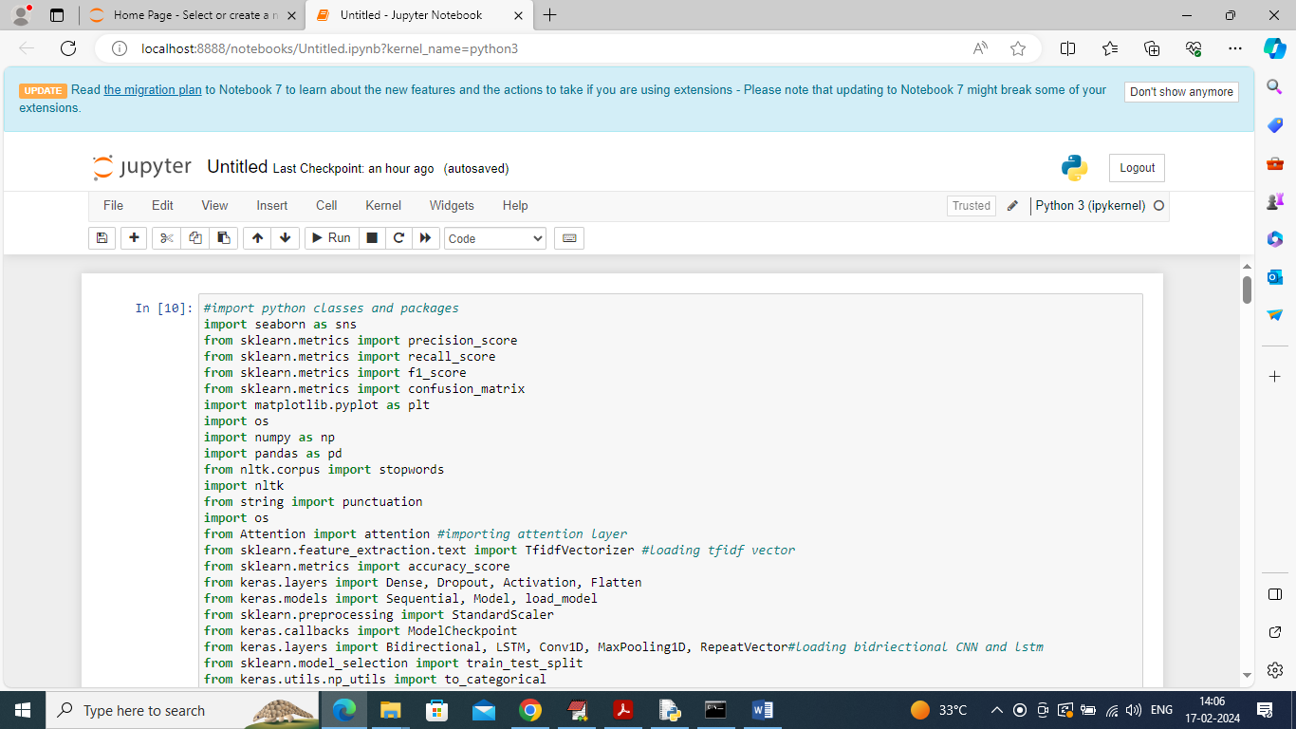

In above screen importing required python classes and packages

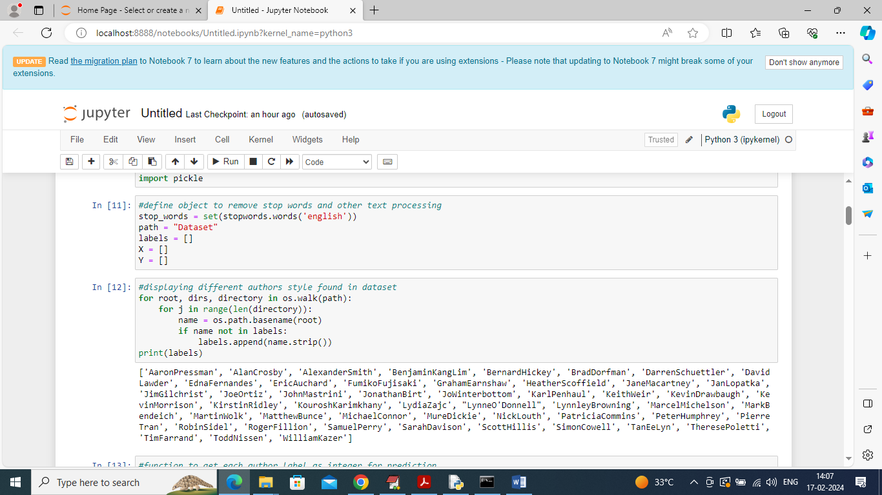

In above screen defining function to remove stop words and to clean text and then displaying all author names available in dataset

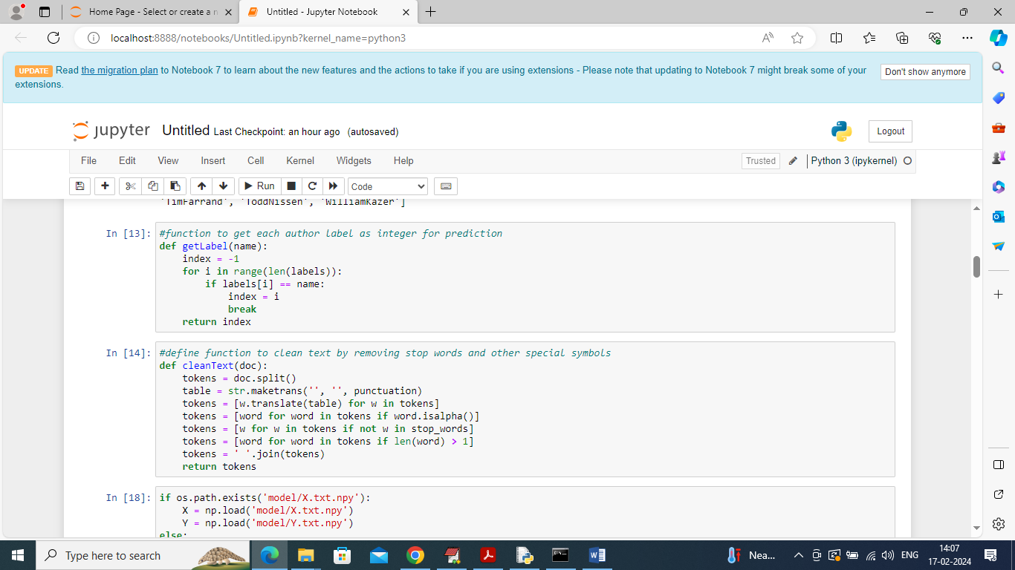

In above screen defined function to clean text like stop words removal, special symbols and numbers etc.

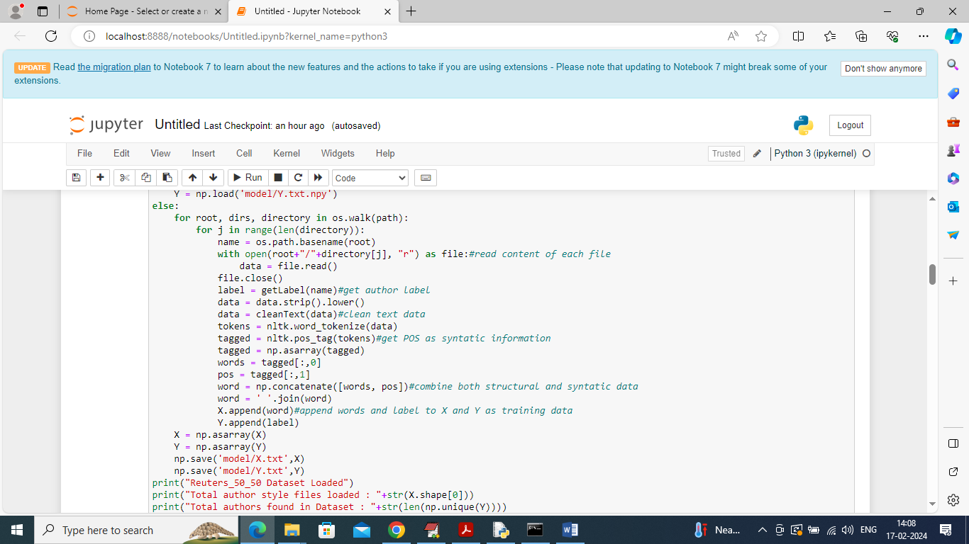

In above screen looping and reading all files from dataset and then cleaning and converting all text files into structure and syntactic information and then adding all process data into X and Y array

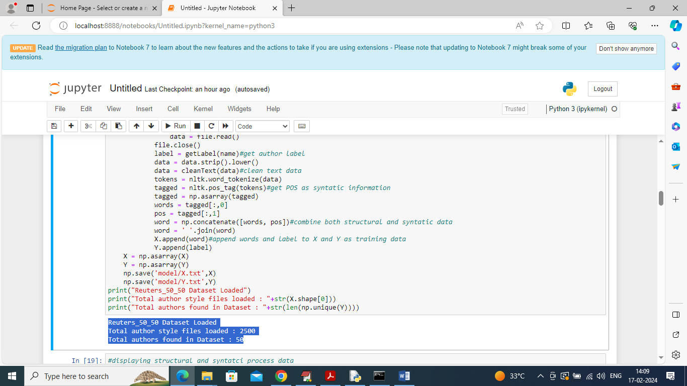

In above screen displaying total files and author available in dataset

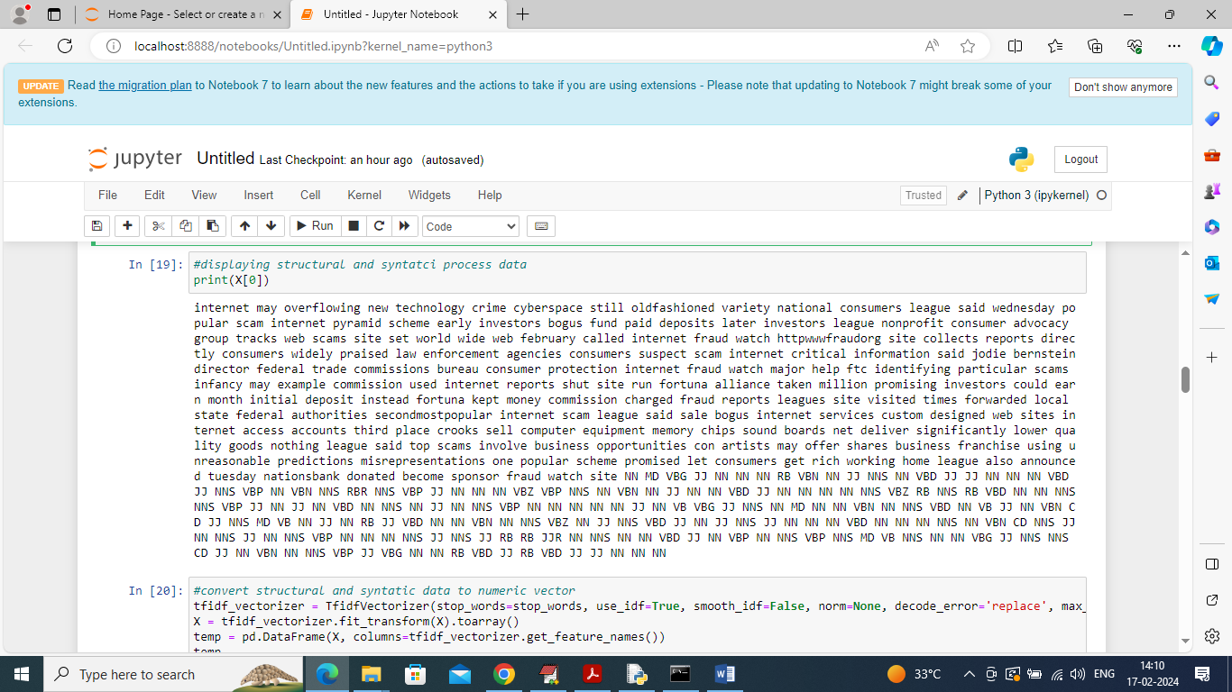

In above screen displaying processed text from one author where we can see structure and syntactic POS values

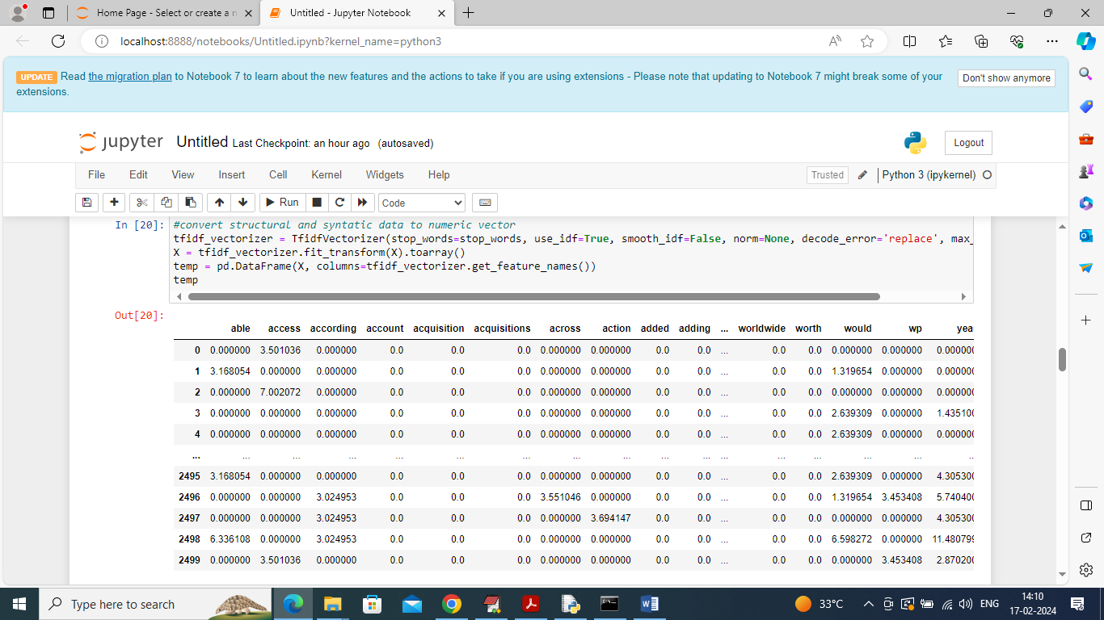

In above screen converting all text into numeric vector where table column contains word names and table rows contains average frequencies of those words

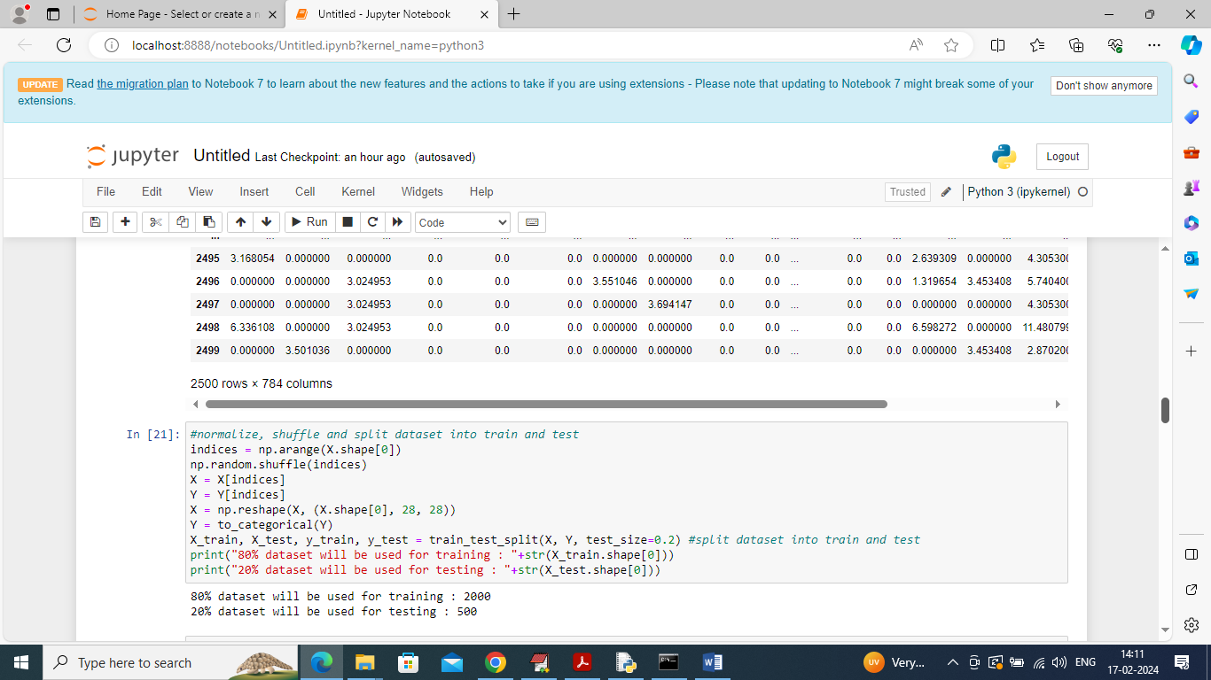

In above screen entire numeric vector is normalizing, shuffling and splitting into train and test where application using 80% for training and 20% for testing

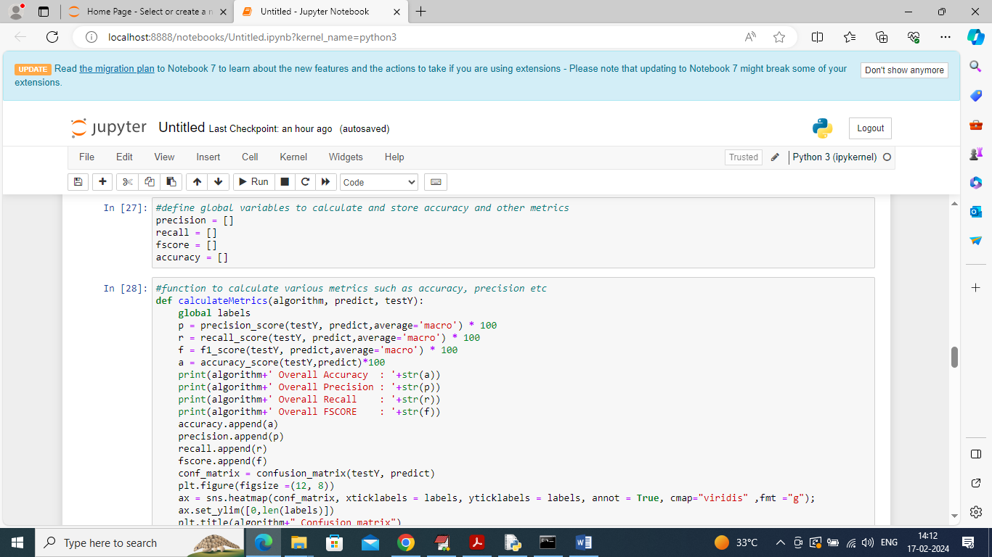

In above screen defining function to calculate accuracy and other metrics

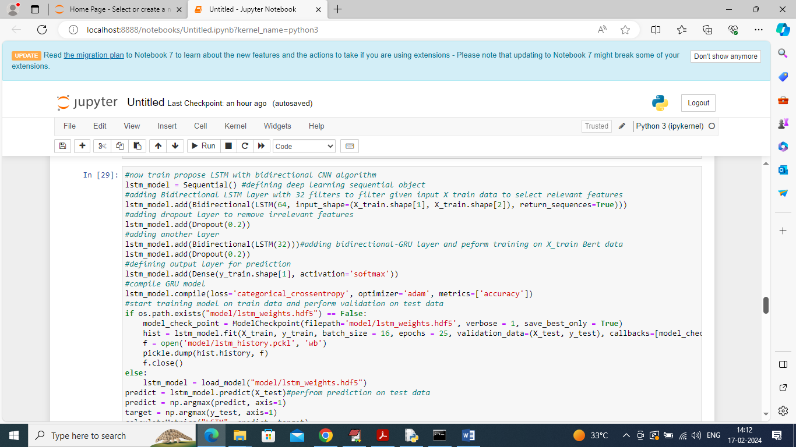

In above screen training LSTM on 80% training data and then performing prediction on 20% test data to calculate prediction accuracy

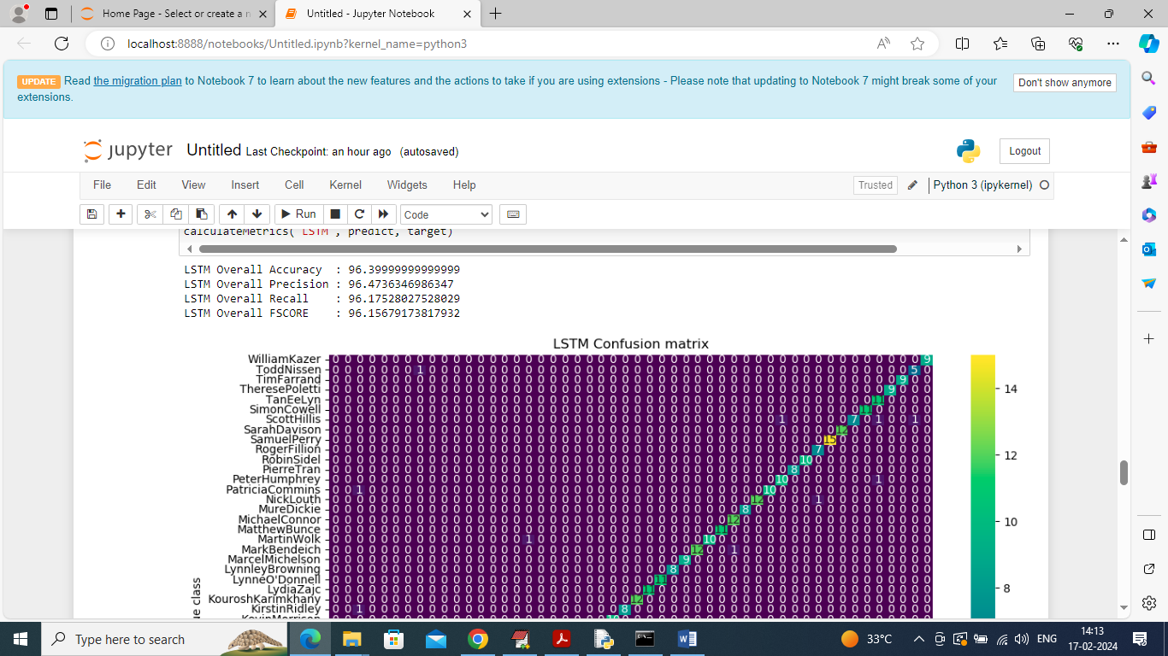

In above screen LSTM got 96% accuracy on 20% test data and can see other metrics like precision, recall etc.

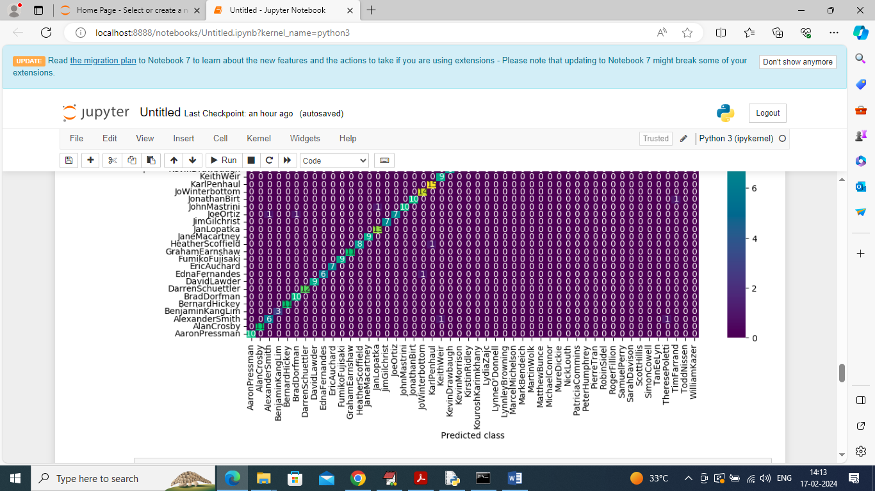

In above confusion matrix graph x-axis represents Predicted Author names and y-axis represents True author names and then all different colour boxes in diagnol represents correct prediction count and remaining blue boxes represents incorrect prediction count which is 0 or very few.

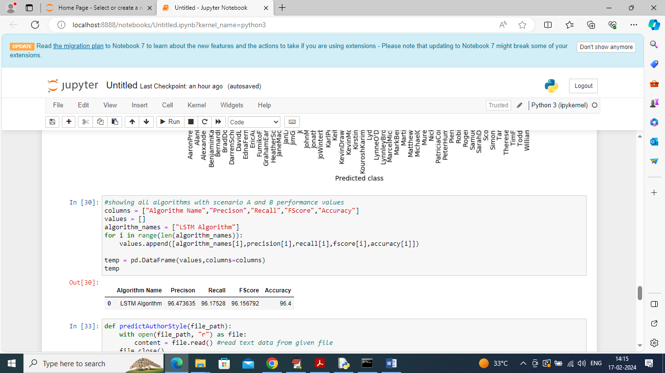

In above screen in table can see LSTM performance

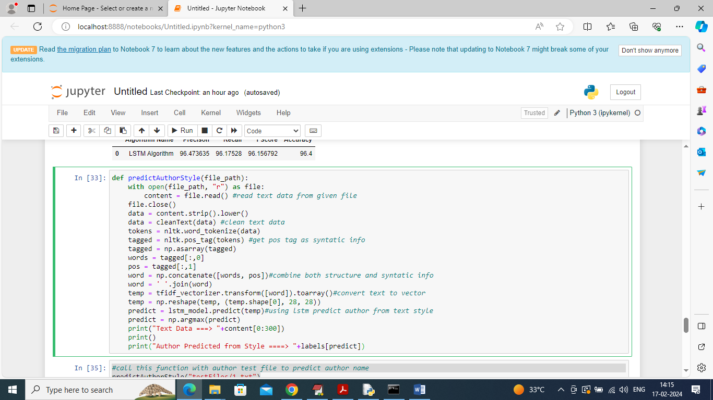

In above screen defining predict function which will take author TEXT file as input and then process text data and then predict author using LSTM based on author style

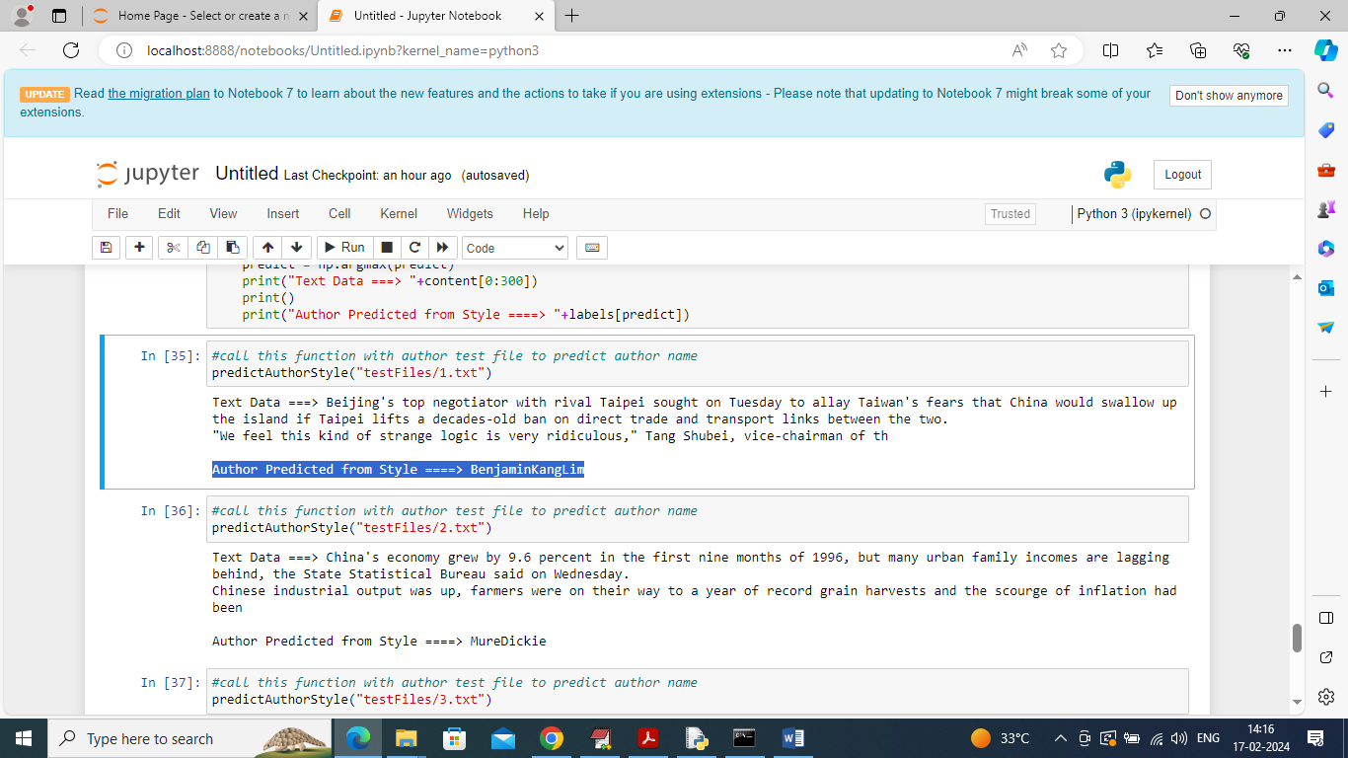

In above screen calling Predict function with author TEXT data and then displaying some content form TEXT data and then after ARROW =🡺 symbol can see predicted author name from given STYLE TEXT

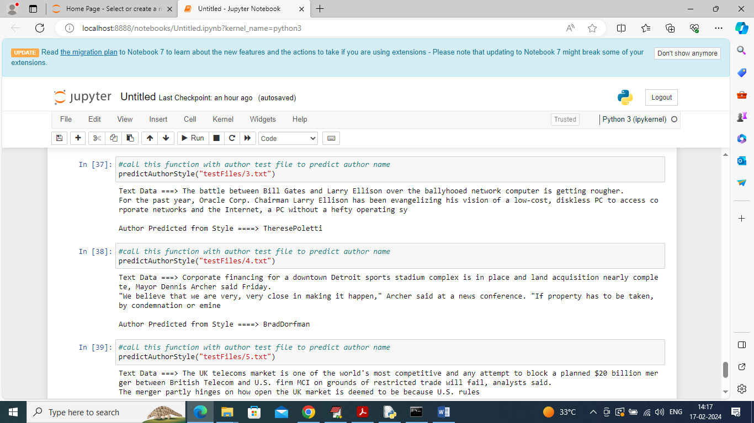

In above screen predicting author from different TEXT style. Similarly by giving any text file you can predict author from given TEXT style

# **CONCLUSION**

Authorship attribution using deep learning has emerged as a promising approach in identifying the author of a given text by analyzing writing style, vocabulary, and syntactic patterns. By leveraging neural networks, especially deep learning architectures like Convolutional Neural Networks (CNNs) and Recurrent Neural Networks (RNNs), researchers have achieved impressive accuracy in differentiating between authors based on subtle nuances in their writing. These models learn hierarchical features from text, moving from simple word or character sequences to more complex structures that capture the essence of an author’s unique style. Deep learning's ability to process massive amounts of textual data and automatically extract relevant features makes it particularly suitable for authorship attribution tasks, where traditional statistical or rule-based methods may fall short.

Despite these advancements, challenges remain in applying deep learning to authorship attribution across diverse contexts. Model interpretability, for instance, is a critical concern; understanding why a model attributes a piece of writing to a particular author can be as important as the attribution itself, especially in legal and forensic applications. Moreover, authorship attribution in deep learning may struggle with texts that are short or contain minimal distinguishing features, as well as with texts that include collaborative authorship or evolve over time. Nonetheless, by incorporating newer techniques such as transfer learning and data augmentation, researchers are finding ways to overcome these challenges, pushing the field toward even more reliable models. In sum, deep learning has reshaped the landscape of authorship attribution, enabling it to handle more complex datasets with higher accuracy, though careful attention to ethical and interpretative considerations will be essential as these technologies are more widely adopted.

# **FUTURE SCOPE OF THE PROJECT**

The future of authorship attribution using deep learning holds tremendous potential across various applications in both academia and industry. As the complexity and amount of textual data increase, deep learning offers a scalable and powerful solution for identifying authorship in documents, books, articles, and even anonymous online content. This technology will likely see wider adoption in areas like legal forensics, social media monitoring, and intellectual property protection. By leveraging deep learning models, authorship attribution can reach new levels of accuracy and reliability, even with limited information or short text samples. Improved models could lead to faster, automated ways of identifying writing patterns, making it an invaluable tool for detecting plagiarism, misinformation, or even malicious intent in digital content.

Future advancements in this field could also involve integrating multimodal data to improve authorship accuracy. For instance, combining stylistic analysis with other markers such as social network metadata or handwriting (where applicable) could provide a more holistic view of authorship. Additionally, as deep learning models continue to improve, they will likely become more interpretable, helping to clarify the unique linguistic features that set one author apart from another. This could foster greater transparency and trust in the technology, particularly in sensitive areas like legal forensics and content moderation. Expanding authorship attribution to include a wider range of languages and dialects, along with more robust handling of mixed-language texts, will broaden its applicability on a global scale, making it a versatile tool for analyzing cross-cultural or multi-language writing.

Furthermore, as generative models like GPT continue to evolve, deep learning for authorship attribution may become instrumental in detecting and verifying human versus AI-generated content. This development could support initiatives to preserve human creativity and ensure originality in digital spaces, particularly as AI-generated text becomes more common.

# **REFERENCES**

1. **Stamatatos, E. (2009).** "A Survey of Modern Authorship Attribution Methods." *Journal of the American Society for Information Science and Technology*, 60(3), 538–556.

Comprehensive survey of authorship attribution techniques, including initial attempts at applying machine learning.

1. **Zhang, S., Zheng, Y., & Zhang, H. (2022).** "A Comprehensive Survey of Authorship Attribution Techniques for Online Social Media." *IEEE Access*, 10, 89442-89463.

Review of deep learning techniques applied to authorship analysis on social media.

1. **Seroussi, Y., Zukerman, I., & Bohnert, F. (2014).** "Authorship Attribution with Latent Dirichlet Allocation." *Proceedings of the 14th Conference of the European Chapter of the Association for Computational Linguistics*.

Explores topic modeling as an intermediary representation for deep learning in authorship tasks.

1. **Kestemont, M., Stover, J., Riddell, A., & Daelemans, W. (2015).** "Authenticating the Writings of Julius Caesar." *Proceedings of the 2015 Conference on Empirical Methods in Natural Language Processing*.

Uses deep learning to authenticate historical authorship, showcasing adaptability to various time periods.

1. **Peng, Y., Li, D., & Lai, S. (2017).** "A Deep Learning Approach for Authorship Attribution Based on Convolutional Neural Networks." *Proceedings of the 31st AAAI Conference on Artificial Intelligence*.

Implements CNNs for the feature extraction of stylistic attributes, improving accuracy.

1. **Shrestha, P., Sierra, G., & Montes, M. (2017).** "Convolutional Neural Networks for Authorship Attribution of Short Texts." *Proceedings of the 15th Conference of the European Chapter of the Association for Computational Linguistics*.

Focuses on applying CNNs to short texts, addressing challenges in sparse information contexts.

1. **Abdi, A., Idris, N., Alguliyev, R., & Aliguliyev, R. (2019).** "Authorship Analysis in Online Social Media via Deep Learning." *IEEE Access*, 7, 95309-95335.

Comprehensive review of deep learning approaches, focusing on online social media.

1. **Ubeda, A., Rangel, F., & Rosso, P. (2018).** "Exploring the Use of Recurrent Neural Networks for Authorship Attribution." *Proceedings of the 27th International Conference on Computational Linguistics*.

Proposes RNN architectures for capturing sequential patterns in text for authorship attribution.

1. **Bojanowski, P., Grave, E., Joulin, A., & Mikolov, T. (2017).** "Enriching Word Vectors with Subword Information." *Transactions of the Association for Computational Linguistics*, 5, 135-146.

Develops word embeddings with subword information, enhancing authorship analysis by capturing nuanced vocabulary usage.

1. **Ge, L., Qian, J., & Tian, Y. (2019).** "Style2Vec: Representation Learning of Writing Style Using CNN-LSTM." *Proceedings of the 2019 Conference on Empirical Methods in Natural Language Processing*.

Introduces CNN-LSTM hybrid model to learn style representations for authorship.

1. **Schwartz, R., Dodds, P., O’Neil-Dunne, J., Danforth, C., & Adams, C. (2013).** "Personality, Gender, and Age in the Language of Social Media: The Open-Vocabulary Approach." *PLOS ONE*, 8(9).

Uses language features to study demographic elements, offering techniques transferable to authorship.

1. **Juola, P. (2006).** "Authorship Attribution." *Foundations and Trends in Information Retrieval*, 1(3), 233–334.

Foundational work outlining the methods, challenges, and early AI applications in authorship analysis.

1. **Koppel, M., & Winter, Y. (2014).** "Determining if Two Documents are by the Same Author." *Journal of the American Society for Information Science and Technology*, 65(1), 178–187.

Investigates methods for authorship verification, forming a baseline for deep learning benchmarks.

1. **Halteren, H., Baayen, R. H., Tweedie, F., & Lavrenko, V. (2005).** "New Machine Learning Methods Demonstrate the Existence of a Human Style Fingerprint." *Literary and Linguistic Computing*, 20(3), 253–263.

Early study showing a "style fingerprint" concept, which later informs neural network approaches.

1. **Brennan, M., & Greenstadt, R. (2009).** "Practical Attacks Against Authorship Recognition Techniques." *Proceedings of the Twenty-First Conference on Innovative Applications of Artificial Intelligence*.

Discusses vulnerability in authorship attribution methods, encouraging improvements through deep learning.

1. **Zheng, R., Li, J., Chen, H., & Huang, Z. (2006).** "A Framework for Authorship Identification of Online Messages: Writing-Style Features and Classification Techniques." *Journal of the American Society for Information Science and Technology*, 57(3), 378–393.

Pioneers authorship identification frameworks, foundational for deep learning adaptations.

1. **Narayanan, A., & Shmatikov, V. (2013).** "Robust De-anonymization of Large Sparse Datasets." *Proceedings of the 2008 IEEE Symposium on Security and Privacy*.

Introduces techniques for deanonymizing datasets, impacting approaches to secure authorship attribution.

1. **Shaham, S., Singer, A., & Ronen, I. (2016).** "On the Authentication of a Real Novel Using Deep Learning Techniques." *Proceedings of the Association for Computational Linguistics*.

Applies deep learning to authenticate literary works, specifically novels, demonstrating deep networks on large texts.

1. **Qian, J., Tian, Y., Wen, R., & Wang, M. (2018).** "Deep Learning for Authorship Attribution of Chinese Novels." *Journal of Computer Science and Technology*, 33(2), 285–298.

Explores the challenges of attributing authorship in Chinese using deep learning.

1. **Buechel, S., & Hahn, U. (2016).** "Emotion Detection in Text: Benchmarking State-of-the-Art Machine Learning Approaches." *Proceedings of the 27th International Conference on Computational Linguistics*.

Studies emotional features in text, which have indirect applications in detecting unique author signatures.